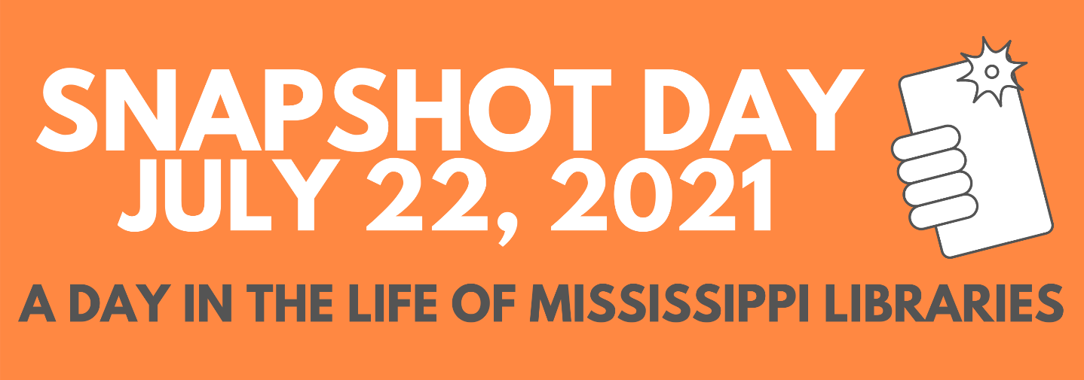

IN JUST ONE DAY AT:

______________
(name of library)

people visited the library (inside and curbside).

books and more were checked out from the library.

people used computers at the library.

questions were answered at the library.

_______________ attended programs at the library.

_______________ programs offered at the library.

Please complete this form and return to MLC by July 30, 2021. Send by email to Ethel Dunn at ethel@mlc.lib.ms.us

