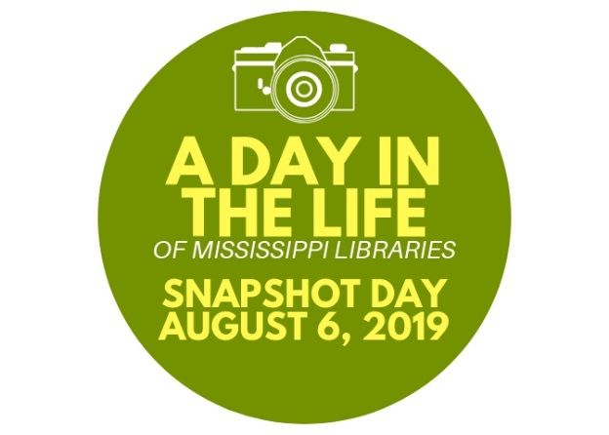
IDEAS TO MAKE SNAPSHOT DAY A
SUCCESS FOR YOUR LIBRARY

- Announce your participation now through emails, flyers, posters, etc.

- Feature your participation and the photos of your patrons from that day in your newsletter, social media and website

- Share the results from the day with your board and elected officials

- Create signs with your patron comments and photos to hang around your library

- Be sure to encourage your patrons to come to the library on August 6th to show their support and get their photo taken

- Take as many photos that day as possible and use them along with comments from patrons throughout the year

- Develop your own slideshow on your website or social media featuring your patron comments and photos

- Ask if your newspaper will feature your slideshow on their website and if they will run photos and comments from the day.

- Use these photos and comments during the legislative session to advocate for libraries

- Encourage your Friends group to get involved

- Send your images and comments to MLC for a Mississippi library collage that will be created to use during the legislative session in 2020…send them to sliles@mlc.lib.ms.us

