Today we’re going to learn how to do so several things with Microsoft Word 2010. We’re going to learn:

- How to turn the ruler on and off;
- Insert a header and a footer;
- Add images and format them;
- Work with columns;
- Work with tabs;
- Work with tables;
- Use headings throughout a document; and
- Hyperlink

The Ruler
There is a ruler at the top of the document and on the left hand side of the document that can come in handy. If you do not see your ruler, you can click the “View Ruler” icon at the top of the right-hand vertical scroll bar.

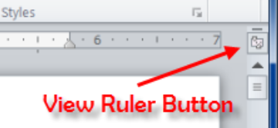

Header & Footer
You can add a header and a footer to your document that will show on top (header) or bottom (footer) of every page. You can also have a different header/footer for the first page.

First, let’s add a header that will serve as the title of this document. This means we will have a different header for the first page compared to the rest of the document.

To activate the header/footer, you can either
- Double click at the top/bottom of your document to activate the header and footer sections, OR
- Go to the Insert tab, click on Header within the Header & Footer group and click “Edit Header’.

Before entering anything in the header, on the new “Design” tab, click in the Options group and check mark “Different First Page”.

- You can begin typing in the new header “MICROSOFT WORD 2010”. Center the header. Bold it. Change the font size to 20.

Now that’s done, let’s add a footer with page numbers for the document. Since we want a page number on every page we will just insert the page number and make no changes for information to be different on the first page.
- On the Insert tab, click the dropdown for “Page Number” and hover over Bottom of Page and select an option.

- Double click at the bottom of your document to activate the footer section, OR
- Go to the Insert tab, click on Footer within the Header & Footer group and click “Edit Footer.
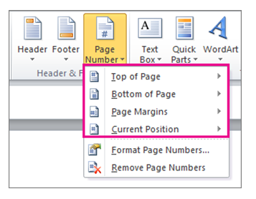

Adding and Formatting Images
To add images, use the Insert tab on the Ribbon. You can click on “Picture” to upload an image from your computer, or you can use the “Clip Art” button to select an image from their collection. Clip Art is no longer available after the 2013 version of Word.

So to start, place your cursor/mouse after this sentence.

- Click on Insert and click on Clip Art. Check mark “Include Office.com content. Search for a keyword. Select an image and insert.

You’ll notice the image was placed in line with the sentence. You can “wrap your image around the text” in your document in several ways. We’re going to make ours “Tight”

- Left click the image to make sure it’s selected. In your ribbon the new “Format” tab shows, and there is a Text Wrapping option, choose “Tight”. Now position the photo where you want it placed.

Columns
Let’s create columns, only in this part of the document.
- Highlight the text you want in columns. Go to the “Page Layout” in the ribbon and use the dropdown menu to select “Three”.

Axis 360 E-Books: The new, all-in-one Axis 360 mobile app is now available for users to download from the Google Play and Apple App Store! The new Axis 360 experience delivers simplicity, providing users with the functionality they need to discover and enjoy digital content instantly, no matter where they are, in three steps or less!

New Microfilm Scanner: The new ST ViewScan II microfilm scanner and computer are now available in the Lincoln County Public Library, the Lawrence County Public Library and the Franklin County Public Library, thanks to several private grants. Genealogy researchers may search each library's collection of microfilm in the library and print or e-mail images.

e-Magazines Now Available!
Directions are available here and iPad download instructions are available here. Apps are available for PC, MAC, iPad, iPhone, Android, Kindle Fire/Fire HD, Nook HD/HD+, Win8 and Blackberry Playbook. Visit your device's app store to download and install the free Zinio reader app or link from the Zinio website (scroll to the bottom of the page).

Let’s make a column break so that each topic is in one column.
- Place your cursor/mouse before the word you want to “break”, in this case it will be “New”. Under page layout, use the “Breaks” dropdown and select “Column”

Tabs
Tabs can help certain documents look better and be easier on the eyes. There are several types:
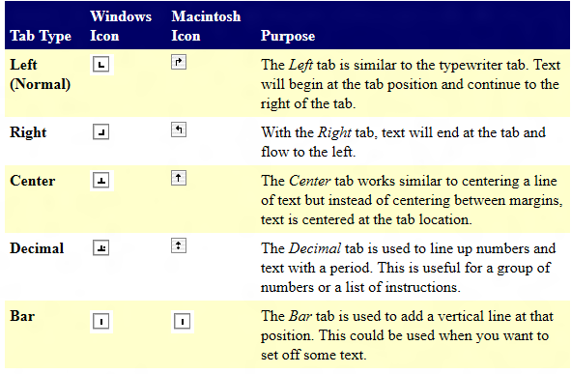

To use tabs, make sure your ruler is activated.
- Select the lines you want to tab. In this case we’ll use the right tab. Place it on the 2 on your ruler. In front of each word place your cursor/mouse in front and press the tab key on your computer.

Name:
E-Mail Address:
Library System:
Branch:
Position:

Fill out the information.
- Select the lines again and add a left tab so your information is lined by placing a left tab on the 2.5 mark.
Tables
- Click on the Insert tab on the ribbon and create a table with 3 rows and 3 columns

Headings
- Select the text you want to use as a heading. On the Home tab of the ribbon, select Heading1.
- Use the Format Painter brush on the Home tab, to make the rest of headings, “true headings”

Hyperlinking
We’re going to create 2 different types of hyperlinks
- Hyperlinks going to websites
  - Mississippi Library Commission
    - www.mlc.lib.ms.us
  - Lincoln-Lawrence-Franklin
    - http://www.llf.lib.ms.us/

- Select the text you want to hyperlink. Right click on and insert hyperlink. In the box under “Address” type in the URL/Address of the website. Click ok.

- Hyperlinks going to places within our document

- Go to top of document. And select one objective. Right click to insert hyperlink and make sure on the left it says “Place in this document”. Select the correct objective. Click Ok.
